~ June 2017 ~
Activities in BOLD indicate an outing or special event. Details are in the Beacon.

See Posted Daily Schedule for unforeseen changes to this calendar

Sunday | Monday | Tuesday |  | Wednesday | Thursday | Friday | Saturday
  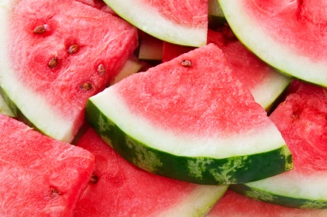 |  |  |  |  | 1  9:00 Walk & Rollers  9:45 Laughter Yoga  10:00 Rosary & Communion (AWR)  10:30 Reminiscing (LR)  1:30 Cardio Drumming  1:30 Knitting with Nancy (LG)  2:30 Cooking Club | 2  9:00 Walk & Rollers  9:30 Music & Movement (GLR)  10:20 Lincoln River Morning  Wakeup (LR)  1:30 Piano W/ Lorrie  2:30 Bingo (LR) | 3  9:15 Movement & Cog Ex (GLR)  1:00 Piano Performance w/ Joan  (AWR)  7:00 Movie Matinee (PDR)*
4  10:00 TV Mass (AWR)  1:00 Walk Club  1:30 Performance w/ Walter Verdehr (AWR)  2:30 Bingo (2CHR)  4:00 Vespers (AWR) | 5  9:00 Walk & Rollers  9:30 Music & Movement (GLR)  10:20 Lincoln River Morning WakeUp  1:30 Bingo (GLLR) | 6  9:00 Walk & Rollers  9:40 Looking Glass Morning  Wakeup (LG)  10:20 Travel Club (LR)  12:30 Mid-Day Walk Club  1:30 Cardio Drumming (AWR)  2:30 Music (LR)  4:15 Gardening  Happy Birthday Chandra M. |  | 7  9:00 Walk & Rollers  9:30 Music & Movement (GLR)  10:20 Lincoln River Morning WakeUp  11:30 Historical Village & Picnic  2:30 Sing Along (RC)  4:00 Farkle (RC) | 8  9:00 Walk & Rollers  9:45 Laughter Yoga  10:00 Rosary & Communion (AWR)  1:30 Cardio Drumming  1:30 Knitting with Nancy (LG)  2:30 Cooking Club  7:00 Piano Performance w/ Char  (AWR) | 9  9:00 Walk & Rollers  9:30 Music & Movement (GLR)  10:20 Lincoln River Morning  Wakeup (LR)  1:30 Piano W/ Lorrie  2:30 Bingo (LR)  3:00 Parkinson’s Dialogue Group  (1 RC Training Room)  6:15 Lake Lansing Bandshell  Concert | 10  9:15 Movement & Cog Ex (GLR)  1:00 Popcorn Social (2)  1:30 Movie Matinee (PDR)  2:00 Unitarian Discussion Group  (AWR)*  Happy Birthday Jan K. & Don W.
11  10:00 TV Mass (AWR)  1:00 Walk Club  1:00 Movie Matinee (LG)  2:30 Bingo (2CHR)  4:00 Vespers (AWR)  7:00 Jug & Mug Sing (AWR) * | 12  9:00 Walk & Rollers  9:30 Music & Movement (GLR)  10:20 Lincoln River Morning WakeUp  1:30 Bingo (GLLR)  Happy Birthday Alice P. | 13  9:00 Walk & Rollers  9:40 Looking Glass Morning  Wakeup (LG)  10:00 Intergenerational Program  (AWR)  12:30 Mid-Day Walk Club  1:30 Cardio Drumming (AWR)  2:30 Tuesday Treats w/ Tom  (Stansell Patio)  4:15 Gardening |  | 14  9:00 Walk & Rollers  9:30 Music & Movement (GLR)  10:20 Lincoln River Morning WakeUp  2:30 Flag Day with Peter B. Stansell  4:00 Wine & Cheese Social 2RC    Happy Birthday Ethel F. | 15  9:00 Walk & Rollers  9:45 Laughter Yoga  10:00 Rosary & Communion (AWR)  10:30 Reminiscing (LR)  1:30 Cardio Drumming  1:30 Knitting with Nancy (LG)  2:30 Cooking Club  7:00 Square Dancing! (4th fl lobby) | 16  9:00 Walk & Rollers  9:00 Lansing Art Gallery & Lunch  9:30 Music & Movement (GLR)  10:20 Lincoln River Morning  Wakeup (LR)  1:30 Alzheimer’s Support Grp  (PDR)  1:30 Piano W/ Lorrie  2:30 Bingo (LR)  5:45 Lugnuts Game Outing | 17  9:15 Movement & Cog Ex (GLR)  2:30 Father’s Day Ice Cream  Social w/ Jay Hill  (Carports)  7:00 Evening Movie (PDR)*
18  Father’s Day  10:00 TV Mass (AWR)  1:00 Walk Club  1:00 Movie Matinee (LG)  2:30 Bingo (2CHR)  4:00 Vespers (AWR) | 19  9:00 Walk & Rollers  9:30 Music & Movement (GLR)  10:20 Lincoln River Morning WakeUp  1:30 Bingo (GLLR)  Happy Birthday Dolores B. | 20  9:00 Walk & Rollers  9:40 Looking Glass Morning  Wakeup (LG)  10:20 Travel Club (LR)  12:30 Mid-Day Walk Club  1:30 Cardio Drumming (AWR)  2:30 Music (LR)  4:15 Gardening |  | 21  9:00 Walk & Rollers  9:30 Music & Movement (GLR)  10:20 Lincoln River Morning WakeUp  2:30 Sing Along (RC)  4:00 Farkle (RC) | 22  9:00 Walk & Rollers  9:00 People’s Church Preschool Visit  9:45 Laughter Yoga  10:00 Rosary & Communion (AWR)  10:30 Reminiscing (LR)  1:30 Cardio Drumming  1:30 Knitting with Nancy (LG)  2:30 Cooking Club | 23  9:00 Walk & Rollers  9:30 Music & Movement (GLR)  10:20 Lincoln River Morning  Wakeup (LR)  11-1:30 Renos Lunch Bunch  1:30 Piano W/ Lorrie  2:30 Bingo (LR) | 24  9:15 Movement & Cog Ex (GLR)  1:00 Popcorn Social (2)  1:30 Movie Matinee (PDR)  2:00 Unitarian Discussion Group  (AWR) *
25  10:00 TV Mass (AWR)  1:00 Walk Club  1:00 Movie Matinee (LG)  2:30 Bingo (2CHR)  4:00 Vespers (AWR)  7:00 Jug & Mug Sing-a-long* | 26  9:00 Walk & Rollers  9:30 Music & Movement (GLR)  9:40 Reminisce (LG)  10:20 Lincoln River Morning WakeUp  1:30 Bingo (GLLR) | 27  9:00 Walk & Rollers  9:40 Looking Glass Morning  Wakeup (LG)  10:20 Travel Club (LR)  12:30 Mid-Day Walk Club  1:00 Episcopal Services (GLR)  1:30 Cardio Drumming (AWR)  2:00 Birds of a Feather * (SVDR)  2:30 Tuesday Treats w/ Wanda  (Stansell Patio)  4:15 Gardening | 28  9:00 Walk & Rollers  9:30 Music & Movement (GLR)  10:20 Lincoln River Morning WakeUp  2:30 Sing Along (RC)  4:00 Wine & Cheese (2RC)  Happy Birthday Therese R. |  | 29  9:00 Walk & Rollers  9:45 Laughter Yoga  10:00 Rosary & Communion (AWR)  10:30 Reminiscing (LR)  1:30 Cardio Drumming  1:30 Knitting with Nancy (LG)  2:30 Senior Class Band Performance  (AWR)  7:00 East Lansing Kiwanis Comm Band  (Outside of AWR) | 30  9:00 Walk & Rollers  9:30 Music & Movement (GLR)  10:20 Lincoln River Morning  Wakeup (LR)  1:30 Piano W/ Lorrie  2:30 Bingo (LR)  7:00 Violin Performance w/ Karel  and Students (AWR)
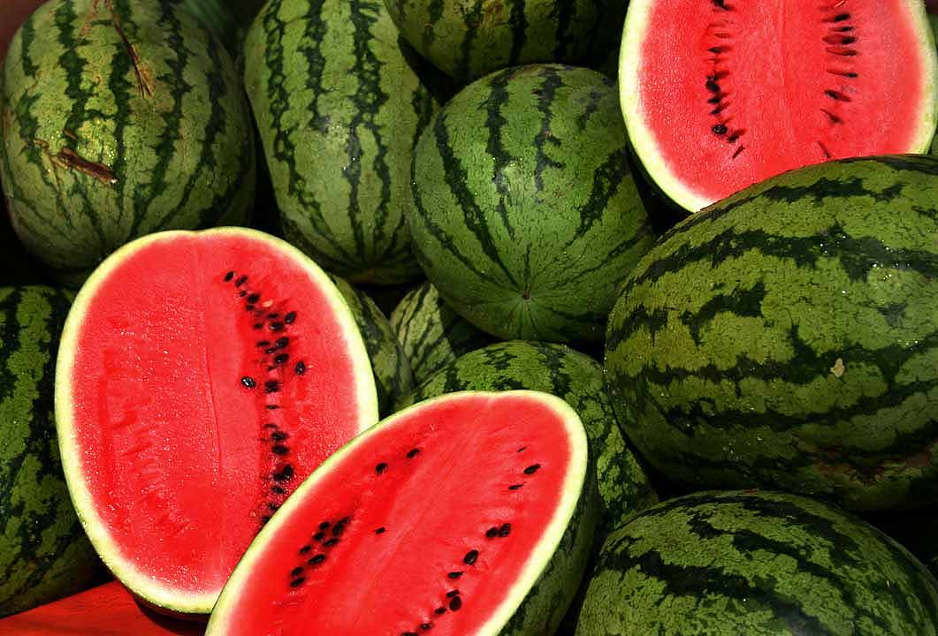
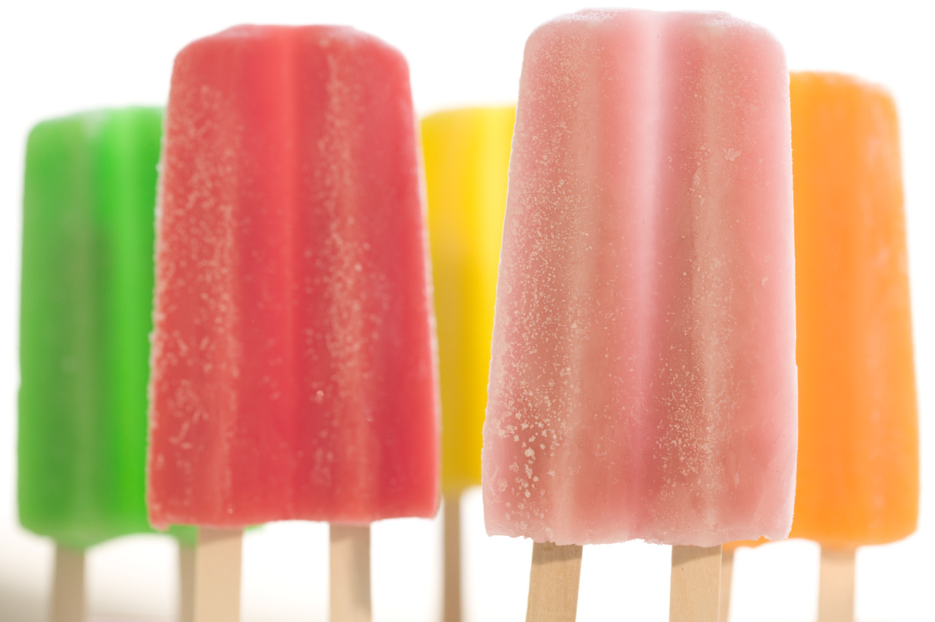
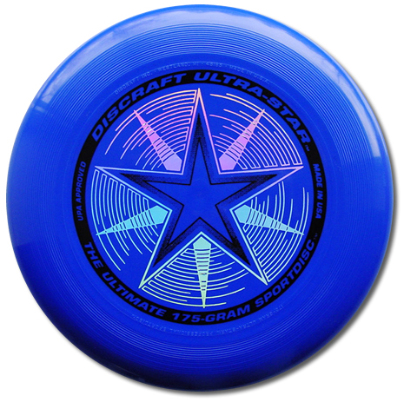
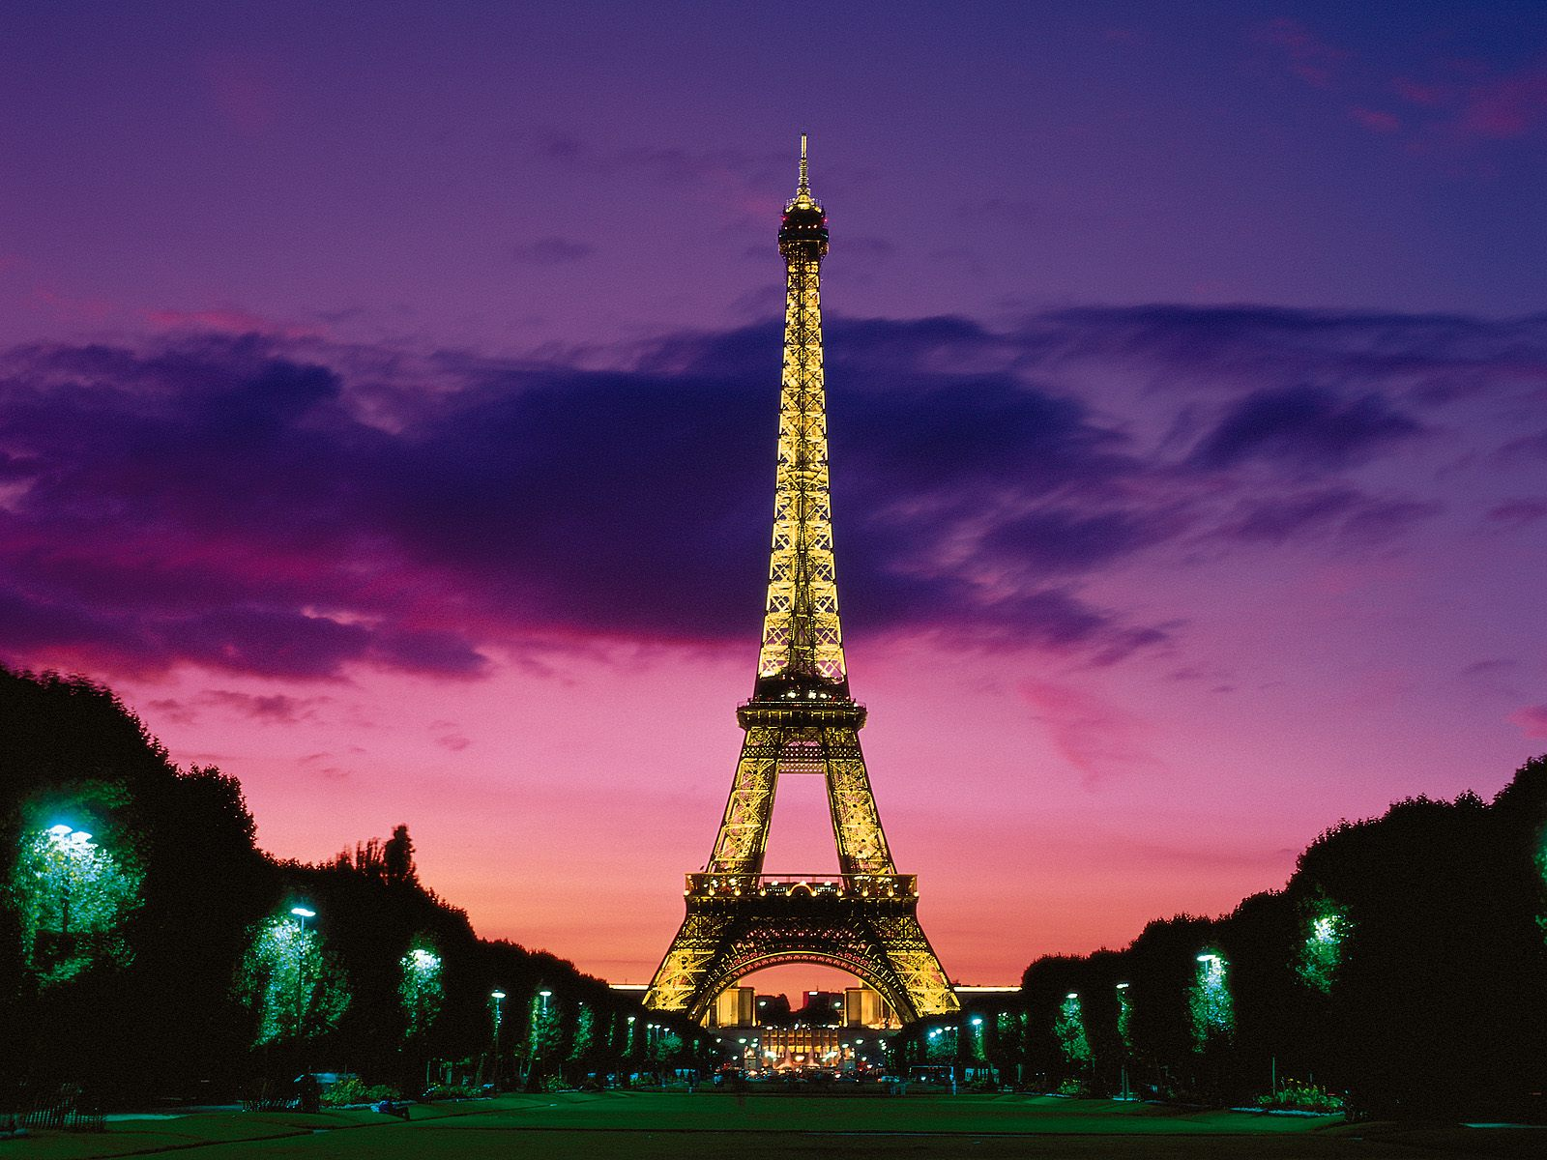
The first day of summer is between June 20th and June 22nd every year. The first day of summer is called the summer solstice, and the day varies due to the Earth’s rotation not exactly reflecting our calendar year.
Watermelon is one of summer’s best summer treats. Did you know that watermelons are not a fruit, but a vegetable instead? They belong to the cucumber family of vegetables.
Frisbees, invented in the 1870’s as a pie plate, but in the 1940’s, college students began throwing them around. They have since stopped being used for pie plates and are now a summertime staple.
In the summer heat, the iron in France’s Eiffel Tower expands, making the tower grow more than 6 inches.
In the summer heat, the iron in France’s Eiffel Tower expands, making the tower grow more than 6 inches.
In the summer heat, the iron in France’s Eiffel Tower expands, making the tower grow more than 6 inches.
Popsicles, a popular summer treat, was accidentally invented by an 11-year-old boy in San Francisco in 1905. He left a glass of soda sitting outside and by the next morning the soda had frozen. He began selling them at an amusement park in New Jersey. In the U.S., cherry is the number 1 flavor
Popsicles, a popular summer treat, was accidentally invented by an 11-year-old boy in San Francisco in 1905. He left a glass of soda sitting outside and by the next morning the soda had frozen. He began selling them at an amusement park in New Jersey. In the U.S., cherry is the number 1 flavor
Ice pops were accidently invented in 1905 by an 11 year old boy in San Francisco. He left a glass of soda sitting outside and by the next morning the soda had frozen. He began selling them at an amusement park in New Jersey, In the U.S, Cherry is the number 1 flavor
Mosquitos are most prevalent during summer months. Mosquitos have been on earth for more than 30 million years.

