~ September 2017 ~
See Posted Daily Activity Schedule
For Unforeseen Changes to this Calendar

Activities in BOLD indicate an outing or special event. Details are in the Beacon.

Sunday | Monday | Tuesday | Wednesday | Thursday | Friday | Saturday
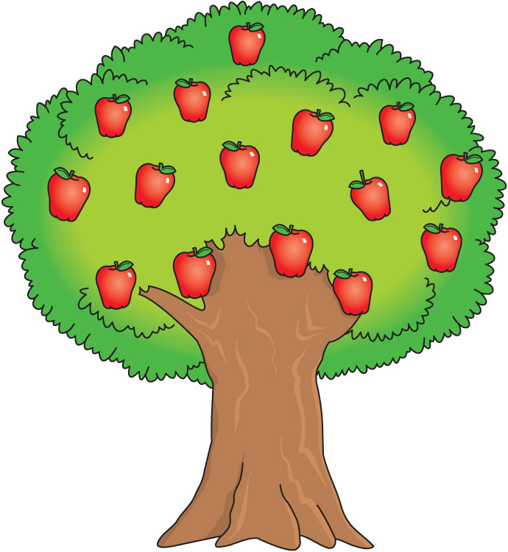 |  |  |  |  | 1  11:30 Labor Day Luau with  Ricky & Nikki (Carports)  2:30 Bingo (CHR-3) | 2  9:30 Exercise (CHR-3)  10:30 Bingo (CHR- 2)  1:30 Current Events (CHR-3)  2:00 Movie & Popcorn (CHR-2)  2:30 Board Games (CHR-3)  4:00 Creative Expression (CHR-3)
3  10:00 TV Mass (AWR)  10:00 Current Events (CHR -2)  11:00 Famous Faces (CHR-3)  1:15 Manicures (CHR-3)  2:00 Chess (CHR-2)  2:30 Bingo (CHR-2)  3:30 Quiddler (CHR-3)  4:00 Vespers (AWR) | 4  *see daily calendar for programs | 5  9:30 Exercise (CHR-2)  10:15 Piano w/ Lorrie (CHR-3)  11:00 Laughter Yoga (AWR)  1:30 Dog Visits (CHR)  2:30 Bingo (CHR-2)  4:00 Creative Expressions (CHR-3)  6:30 MI History Group (2CHR Cozy Corner) | 6  9:30 Exercise (CHR-2)  10:00 Quilting for a Cause (CHR-2)  10:30 Bingo (CHR-3)  1:30 Potter’s Park Zoo Outing (2RC)  2:30 Cooking Group (CHR-2)  3:30 Active Games (CHR-3) | 7  9:30 Exercise (CHR-2)  10:00 Rosary & Communion (AWR)  10:15 FITness Class (CHR-3)  10:30 Yahtzee (CHR-3)  11:00 2CHR Lunch Outing  McDonald’s & Picnic  1:30 Stroke Ed/Support Group (PDR)  3:00 Kings Corner (CHR-3)  4:15 Bird Care (Aviary CHR-1) | 8  9:30 Exercise (CHR-2)  10:30 Card Club (CHR-3)  1:15 Wii Bowling (CHR-3)  2:30 Bingo (CHR-3)  3:00 Parkinson’s Disease Dialogue  Group (PDR)  4:00 Piano w/ Marvin (CHR-3)  4:15 Manicures (CHR-2) | 9  9:30 Exercise (CHR-3)  10:30 Bingo (CHR- 2)  2:30 Grandparent’s Day Social  With Lee Piper (AWR)  4:00 Creative Expression (CHR-3)
10  10:00 TV Mass (AWR)  10:00 Current Events (CHR -2)  11:00 Famous Faces (CHR-3)  1:15 Manicures (CHR-3)  2:00 Chess (CHR-2)  2:30 Bingo (CHR-2)  3:30 Quiddler (CHR-3)  4:00 Vespers (AWR) | 11  9:30 Exercise (CHR-2)  10:00 Reading Group (CHR-2)  10:15 Daily Devotions (CHR-2)  10:30 Card-O (CHR-3)  2:30 Cooking Group (CHR-3)  4:00 Creative Expressions (CHR-2)  6:45 Bingo (CHR-3) | 12  9:30 Exercise (CHR-2)  10:15 Piano w/ Lorrie (CHR-3)  11:00 Laughter Yoga (AWR)  11:00 Exercise (CHR-3)  1:00 Country Mill Outing (2RC)  1:30 Dog Visits (CHR)  2:30 Bingo (CHR-2)  4:00 Creative Expressions (CHR-3)  6:30 MI History Group (PDR) | 13  9:30 Exercise (CHR-2)  10:00 Intergenerational  Workout ( 3CHR)  10:00 Quilting for a Cause (CHR-2)  2:30 Cooking Group (CHR-2)  3:30 Active Games (CHR-3) | 14  9:30 Exercise (CHR-2)  10:00 Catholic Mass (AWR)  10:15 FITness Class (CHR-3)  10:30 Yahtzee (CHR-3)  10:30 Bingo Basket (CHR-3)  11:00 Bingo Basket (CHR-2)  1:30 Musical Memories – (CHR-2)  4:15 Bird Care (Aviary CHR-1)  7:00 Campfire Treats with Peter  Bergin (Stansell Patio) | 15  9:30 Exercise (CHR-2)  10:30 Card Club (CHR-3)  12:00 Burcham Hills “Walk to End  Alzheimer’s” (outside)  1:15 Wii Bowling (CHR-3)  1:30 Alzheimer’s Support  Group (PDR)  1:30 Preuss Pets Animals  (Outside AWR)  2:30 Bingo (Outside AWR)  4:15 Manicures (CHR-2) | 16  9:30 Exercise (CHR-3)  10:30 Bingo (CHR- 2)  1:30 Current Events (CHR-3)  2:00 Movie & Popcorn (CHR-2)  2:30 Board Games (CHR-3)  4:00 Creative Expression (CHR-3)
17  10:00 TV Mass (AWR)  10:00 Current Events (CHR -2)  11:00 Famous Faces (CHR-3)  2:00 Chess (CHR-2)  2:30 Bingo (CHR-2)  3:30 Quiddler (CHR-3)  4:00 Vespers (AWR) | 18  9:30 Exercise (CHR-2)  10:00 Reading Group (CHR-2)  10:15 Daily Devotions (CHR-2)  10:30 Card-O (CHR-3)  12:00 Gadget Workshop (2RC Lobby)  2:30 Cooking Group (CHR-3)  4:00 Creative Expressions (CHR-2)  6:45 Bingo (CHR-3) | 19  9:30 Exercise (CHR-2)  10:15 Piano w/ Lorrie (CHR-3)  11:00 Laughter Yoga (AWR)  11:00 Exercise (CHR-3)  1:30 Dog Visits (CHR)  2:30 Bingo (CHR-2)  4:00 Creative Expressions (CHR-3)  6:30 MI History Group (PDR) | 20  9:30 Exercise (CHR-2)  10:00 Quilting for a Cause (CHR-2)  10:30 Bingo (CHR-3)  2:30 Cooking Group (CHR-2)  3:00 “Happy Hour” (1CHR) | 21  9:30 Exercise (CHR-2)  10:00 Rosary & Communion (AWR)  10:15 FITness Class (CHR-3)  10:30 Yahtzee (CHR-3)  10:30 Bingo Basket (CHR-3)  11:00 Bingo Basket (CHR-2)  12:30 3CHR Event Outing  Potters Park (2RC)  4:15 Bird Care (Aviary CHR-1) | 22  9:30 Exercise (CHR-2)  10:30 Card Club (CHR-3)  1:15 Wii Bowling (CHR-3)  2:30 Bingo (CHR-3)  4:00 Piano w/ Marvin (CHR-3)  4:15 Manicures (CHR-2)  6:00 Haslett H.H. Football  Game (2RC) | 23  9:30 Exercise (CHR-3)  10:30 Bingo (CHR- 2)  1:30 Current Events (CHR-3)  2:00 Movie & Popcorn (CHR-2)  2:30 Board Games (CHR-3)  4:00 Creative Expression (CHR-3)
24  10:00 TV Mass (AWR)  10:00 Current Events (CHR -2)  11:00 Famous Faces (CHR-3)  1:30 Violin & Piano Performance  w/ Marv & Jing Hu (AWR)  3:30 Quiddler (CHR-3)  4:00 Vespers (AWR) | 25  9:30 Exercise (CHR-2)  10:00 Reading Group (CHR-2)  10:15 Daily Devotions (CHR-2)  10:30 Card-O (CHR-3)  1:15 Word Searches (CHR-2)  2:00 Men’s Event:  WWII Movie (AWR)  6:45 Bingo (CHR-3) | 26  9:30 Exercise (CHR-2)  10:15 Piano w/ Lorrie (CHR-3)  11:00 Laughter Yoga (AWR)  11:00 Exercise (CHR-3)  1:30 Dog Visits (CHR  2:30 Bingo (CHR-2)  2:30 Neighborhood meeting (CHR-3)  3:00 3rd Floor Birthday Party  (CHR-3)  6:30 MI History Group (PDR) | 27  9:30 Exercise (CHR-2)  10:00 Bingo (CHR-3)  10:00 Quilting for a Cause (CHR-2)  11:00 Resident Council (CHR-3)  2:30 Cooking Group (CHR-2)  3:30 Book Club (CHR-3) | 28  9:30 Exercise (CHR-2)  10:00 Rosary & Communion (AWR)  10:15 FITness Class (CHR-3)  10:30 Yahtzee (CHR-3)  10:30 Bingo Basket (CHR-3)  11:00 Bingo Basket (CHR-2)  1:30 Musical Memories (CHR-2)  3:00 Neighborhood Meeting (CHR-2)  3:30 2nd Floor Birthday Party (CHR-2) | 29  9:30 Exercise (CHR-2)  10:30 Card Club (CHR-3)  11:00 Lunch Bunch Outing (2RC)  1:15 Wii Bowling (CHR-3)  2:30 Bingo (CHR-3)  4:15 Manicures (CHR-2) | 30  9:30 Exercise (CHR-3)  10:30 Bingo (CHR- 2)  1:30 Current Events (CHR-3)  2:00 Movie & Popcorn (CHR-2)  2:30 Board Games (CHR-3)  4:00 Creative Expression (CHR-3)
