~ June 2019 ~
See Posted Daily Activity Schedule
For Unforeseen Changes to this Calendar

Activities in BOLD indicate an outing or special event. Details are in the Beacon.

Sunday | Monday | Tuesday | Wednesday | Thursday | Friday | Saturday
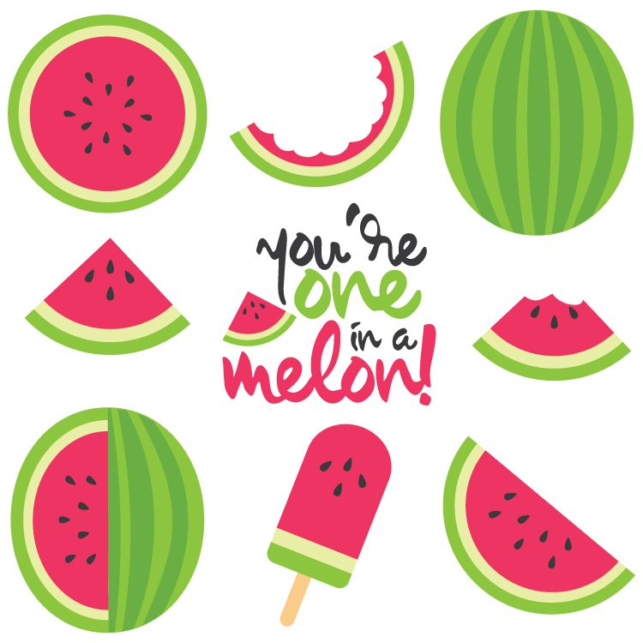  Over 1,200 varieties of watermelon are grown worldwide.  Not only does it quench your thirst, it can also quench inflammation that contributes to conditions like asthma, atherosclerosis, diabetes, colon cancer, and arthritis.  Americans eat more watermelon by weight than any other fruit. Watermelon producers in America grow more than 4 billion pounds of watermelon annually.  Watermelon is an ideal health food because it doesn’t contain any fat or cholesterol, is high in fiber and vitamins A & C and is a good source of potassium. |  |  |  |  |  | 1  9:30 Exercise (3CHR)  10:30 Bingo (2CHR)  1:30 Movie Matinee (2CHR)  1:45 Farkle (3CHR)  3:00 Piano Recital with Miho S.  and Students (AWR)
2  10:00 TV Mass (AWR)  10:00 Current Events (2CHR)  10:30 Religious Hymns on TV (2CHR)  10:45 “Old Time Religion” on TV (3CHR)  11:00 Artist Studio (3CHR)  1:15 Manicures (3CHR)  2:00 Chess (2CHR)  2:30 Bingo (3CHR)  4:00 Vespers (AWR) | 3  9:30 Exercise (2CHR)  10:00 Reading Group (2CHR)  10:15 Daily Devotions (2CHR)  10:30 Quiddler (3CHR)  1:15 Word Searches (3CHR)  2:00 Cooking Group (3CHR)  2:30 Exercise & Parkinson’s (AWR)  4:00 Garden Club (2CHR)  6:30 Bingo (3CHR) | 4  9:30 Exercise (2CHR)  10:00 Piano w/ Lorrie (3CHR)  11:15 Boxing Club (3CHR)  1:15 Musical Memories (3CHR)  2:30 Tuesday Treats  w/Jay Hill (AWR)  4:00 Garden Club (3CHR)  6:30 MI History Group (4RC) | 5  9:30 Exercise (2CHR)  10:00 Quilting for a Cause (2CHR)  10:30 Bingo (3CHR)  12:30 2CHR Event Outing (2RC)  2:00 Cooking Group (2CHR)  2:30 Stroke Ed/Support Group (PDR)  4:00 Basketball Toss (3CHR) | 6  9:30 Exercise (2CHR)  10:00 Rosary & Communion (AWR)  10:15 Yahtzee (3CHR)  11:15 Cardio Drumming (3CHR)  1:30 Musical Memories (2CHR)  1:30 Laughter Yoga (AWR)  2:00 Mediation Moment (AWR)  3:00 Euchre (3CHR)  4:15 Bird Care (Aviary 1CHR)  7:00 Thursday Night Special:  Cello Recital with Char S.  and students (AWR) | 7  9:30 Exercise (2CHR)  10:30 Brain Booster (3CHR)  1:15 Wii Bowling (3CHR)  2:30 Bingo (3CHR)  4:00 Artist Studio with Sarah (AWR) | 8  9:30 Exercise (3CHR)  10:30 Bingo (2CHR)  1:30 Movie Matinee (2CHR)  1:45 Farkle (3CHR)  2:00 Piano Recital with Joan W.  and students (AWR)  4:00 Creative Expression (3CHR)
9  10:00 TV Mass (AWR)  10:00 Current Events (2CHR)  10:30 Religious Hymns on TV (2CHR)  10:45 “Old Time Religion” on TV (3CHR)  11:00 Artist Studio (3CHR)  1:15 Manicures (3CHR)  2:00 Chess (2CHR)  2:30 Bingo (3CHR)  4:00 Vespers (AWR) | 10  9:30 Exercise (2CHR)  10:00 Reading Group (2CHR)  10:15 Daily Devotions (2CHR)  10:30 Quiddler (3CHR)  1:15 Word Searches (3CHR)  2:00 Cooking Group (3CHR)  3:30 Karaoke (3CHR)  4:00 Garden Club (2CHR)  6:30 Bingo (3CHR) | 11  9:30 Exercise (2CHR)  10:00 Art Appreciation Outing:  Broad Museum (2RC)  10:00 Piano w/ Lorrie (3CHR)  11:15 Boxing Club (3CHR)  1:15 Musical Memories (3CHR)  3:00 Lansing Ignite  Meet & Greet (AWR)  6:30 MI History Group (PDR) | 12  9:30 Exercise (2CHR)  10:00 Quilting for a Cause (2CHR)  10:30 Bingo (3CHR)  2:00 Cooking Group (2CHR)  4:00 Basketball Toss (3CHR) | 13  9:30 Exercise (2CHR)  10:00 Catholic Mass (AWR)  10:15 Yahtzee (3CHR)  11:15 Cardio Drumming (3CHR)  1:30 Laughter Yoga (AWR)  2:00 Mediation Moment (AWR)  2:00 Bible Study (3CHR)  3:00 Euchre (3CHR)  4:15 Bird Care (Aviary 1CHR)  6:00 “Hairspray” the Musical  @ Riverwalk (2RC) | 14  9:30 Exercise (2CHR)  10:30 Brain Booster (3CHR)  1:30 Preuss Pets Animals (AWR)  2:30 Bingo (AWR)  3:00 Parkinson’s Disease  Dialogue Group (PDR)*  4:00 Piano w/ Marvin (3CHR)  4:15 Manicures (2CHR) | 15  9:30 Exercise (3CHR)  10:30 Bingo (2CHR)  1:30 Movie Matinee (2CHR)  2:30 Father’s Day Social with  Johnathan Stars (Carports)
16  10:00 TV Mass (AWR)  10:00 Current Events (2CHR)  10:30 Religious Hymns on TV (2CHR)  10:45 “Old Time Religion” on TV (3CHR)  11:00 Artist Studio (3CHR)  2:00 Chess (2CHR)  2:30 Bingo (3CHR)  4:00 Vespers (AWR) | 17  9:30 Exercise (2CHR)  10:00 Reading Group (2CHR)  10:15 Daily Devotions (2CHR)  10:30 Quiddler (3CHR)  1:15 Word Searches (3CHR)  2:30 Walter Verdehr  and Colleagues (AWR)  4:30 Garden Club (2CHR)  6:30 Bingo (3CHR) | 18  9:30 Exercise (2CHR)  10:00 Piano w/ Lorrie (3CHR)  11:15 Boxing Club (3CHR)  2:30 Men’s Event: Outdoor Games  (Outside the AWR)  6:30 MI History Group (PDR) | 19  9:30 Exercise (2CHR)  10:00 Quilting for a Cause (2CHR)  10:00 Bingo Prize Cart (3CHR)  10:30 Bingo (3CHR)  2:30 “Happy Hour” (2CHR)  3:10 “Happy Hour” (3CHR)  6:15 Lansing Ignite Game (2RC) | 20  9:30 Exercise (2CHR)  10:00 Rosary & Communion (AWR)  10:15 Yahtzee (3CHR)  11:00 3CHR Lunch Outing (2RC)  11:15 Cardio Drumming (3CHR)  1:30 Musical Memories (2CHR)  1:30 Laughter Yoga (AWR)  2:00 Mediation Moment (AWR)  3:00 Euchre (3CHR)  4:15 Bird Care (Aviary 1CHR) | 21  9:30 Exercise (2CHR)  10:15 University Lutheran Church  Youth Summer Camp  Performance (AWR)  1:15 Wii Bowling (3CHR)  1:30 Alzheimer’s Support Group (PDR)  2:00 Pam’s Fair Well Open House (AWR)  2:30 Bingo (3CHR)  4:15 Manicures (2CHR) | 22  9:30 Exercise (3CHR)  10:30 Bingo (2CHR)  1:30 Movie Matinee (2CHR)  1:45 Farkle (3CHR)  2:30 Piano Recital w/Judy McCoy  and Students (AWR)
23  10:00 TV Mass (AWR)  10:00 Current Events (2CHR)  10:30 Religious Hymns on TV (2CHR)  10:45 “Old Time Religion” on TV (3CHR)  11:00 Artist Studio (3CHR)  1:15 Manicures (3CHR)  2:00 Chess (2CHR)  2:30 Bingo (3CHR)  4:00 Vespers (AWR) | 24  9:30 Exercise (2CHR)  10:00 Reading Group (2CHR)  10:15 Daily Devotions (2CHR)  10:30 Quiddler (3CHR)  1:15 Word Searches (3CHR)  3:00 2nd Floor Birthday Party 2CHR)  6:30 Bingo (3CHR) | 25  7:30 Women’s Breakfast (AWR)  9:30 Exercise (2CHR)  10:00 Piano w/ Lorrie (3CHR)  11:15 Boxing Club (3CHR)  2:30 Bingo (2CHR)  3:00 3rd Floor Birthday Party (3CHR) | 26  9:30 Exercise (2CHR)  10:00 Quilting for a Cause (2CHR)  10:00 Bingo (3CHR)  11:00 Resident Council (3CHR)  2:00 Bible Study (3CHR)  2:00 Cooking Group (2CHR)  4:00 Basketball Toss (3CHR) | 27  9:30 Exercise (2CHR)  10:00 Rosary & Communion (AWR)  10:15 Yahtzee (3CHR)  11:15 Cardio Drumming (3CHR)  2:30 Brushes & Brews (AWR)  4:15 Bird Care (Aviary 1CHR) | 28  9:30 Exercise (2CHR)  10:30 Brain Booster (3CHR)  1:15 Wii Bowling (3CHR)  2:30 Bingo (3CHR)  4:00 Artist Studio with Sarah (AWR)  4:00 Piano w/ Marvin (3CHR)  6:15 Lake Lansing Bandshell  Outing – 70’s & 80’s (2RC) | 29  9:30 Exercise (3CHR)  10:30 Bingo (2CHR)  1:30 Movie Matinee (2CHR)  1:45 Farkle (3CHR)  3:00 Michigan History (3CHR)  3:00 Cardio Drumming (GLR)  4:00 Creative Expression (3CHR)
30
10:00 TV Mass (AWR)
10:00 Current Events (2CHR)
10:30 Religious Hymns on TV (2CHR)
10:45 “Old Time Religion” on TV (3CHR)
11:00 Artist Studio (3CHR)
1:15 Manicures (3CHR)
2:00 Chess (2CHR)
2:30 Bingo (3CHR)
4:00 Vespers (AWR)
Summer Picnic Sunshine Ice Cream Vacation Beach Lemonade Swimming BBQ

Campfire Relax Thunderstorms Road Trip Travel S’mores Flip Flips Gardening

