~ August 2019 ~
Activities in BOLD indicate an outing or special event. Details are in the Beacon.

See Posted Daily Activity Schedule
For Unforeseen Changes to this Calendar

Sunday | Monday | Tuesday | Wednesday | Thursday | Friday | Saturday
 |  |  |  | 1  9:30 Exercise (2CHR)  10:00 Rosary & Communion (AWR)  10:00 Bingo (3CHR)  11:15 Cardio Drumming (3CHR)  1:30 Laughter Yoga (AWR)  2:30 Photography Workshop (AWR)  3:00 Euchre (3CHR)  4:15 Bird Care (Aviary 1CHR)  7:00 Thursday Night Special: East  Lansing Kiwanis Band (AWR) | 2  9:30 Exercise (2CHR)  10:00 Living to Learn (3CHR)  1:15 Wii Bowling (3CHR)  2:30 Bingo (3CHR)  3:45 Manicures (2CHR) | 3  9:30 Exercise (3CHR)  10:30 Bingo (2CHR)  1:30 Movie Matinee (2CHR)  1:45 Farkle (3CHR)  3:00 Michigan History (3CHR)  3:00 Cardio Drumming (GLR)
4  10:00 TV Mass (AWR)  10:00 Current Events (2CHR)  10:30 Religious Hymns on TV (2CHR)  10:45 “Old Time Religion” on TV (3CHR)  11:00 Artist Studio (3CHR)  1:15 Manicures (3CHR)  2:00 Chess (2CHR)  2:30 Bingo (3CHR)  4:00 Vespers (AWR) | 5  9:30 Exercise (2CHR)  10:00 Living To Learn (3CHR)  11:00 Quiddler (3CHR)  1:15 Word Searches (3CHR)  2:00 Cooking Group (3CHR)  4:00 Garden Club (2CHR)  6:15 Bingo (3CHR) | 6  9:30 Exercise (2CHR)  10:00 Piano w/ Lorrie (3CHR)  10:45 FITness Class (3CHR)  11:15 Boxing Club (3CHR)  1:15 Musical Memories (3CHR)  2:30 Quilting for a Cause (2CHR)  2:30 Bingo (2CHR)  4:00 Bible Study hosted by  Jehovah Witness’s (AWR)  4:00 Garden Club (3CHR)  6:30 MI History Group (PDR) | 7  9:30 Exercise (2CHR)  10:00 Living To Learn (3CHR)  11:00 Yahtzee (3CHR)  12:30 2CHR Event Outing (2RC) canceled  2:00 Cooking Group (2CHR)  2:30 Stroke Ed/Support Group (PDR)  4:00 Basketball Toss (3CHR) | 8  9:30 Exercise (2CHR)  10:00 Catholic Mass (AWR)  10:00 Bingo (3CHR)  11:15 Cardio Drumming (3CHR)  1:30 Laughter Yoga (AWR)  2:00 Bible Study (3CHR)  3:00 Euchre (3CHR)  4:15 Bird Care (Aviary 1CHR) | 9  9:30 Exercise (2CHR)  10:00 Living to Learn (3CHR)  11:00 Lunch Bunch Outing (2RC)  1:15 Wii Bowling (3CHR)  2:30 Bingo (3CHR)  3:00 Parkinson’s Disease  Dialogue Group (PDR)*  3:45 Piano w/ Marvin (3CHR)  4:00 Artist Studio (AWR) | 10  9:30 Exercise (3CHR)  10:30 Bingo (2CHR)  1:30 Movie Matinee (2CHR)  1:45 Farkle (3CHR)  3:00 Creative Expressions (3CHR)  3:00 Cardio Drumming (GLR)
11  10:00 TV Mass (AWR)  10:00 Current Events (2CHR)  10:30 Religious Hymns on TV (2CHR)  10:45 “Old Time Religion” on TV (3CHR)  11:00 Artist Studio (3CHR)  1:15 Manicures (3CHR)  2:00 Chess (2CHR)  2:30 Bingo (3CHR)  4:00 Vespers (AWR) | 12  9:30 Exercise (2CHR)  10:00 Living To Learn (3CHR)  11:00 Quiddler (3CHR)  1:15 Word Searches (3CHR)  2:00 Cooking Group (3CHR)  4:00 Garden Club (2CHR)  6:15 Bingo (3CHR) | 13  9:30 Exercise (2CHR)  10:00 Piano w/ Lorrie (3CHR)  10:45 FITness Class (3CHR)  11:15 Boxing Club (3CHR)  2:00 Dessert Wars and  Ukulele Performance (AWR)  4:00 Bible Study hosted by  Jehovah Witness’s (PDR)  4:00 Garden Club (3CHR)  6:30 MI History Group (PDR) | 14  9:30 Men’s Event:  Fishing Trip (2RC)  2:00 Cooking Group (2CHR)  3:00 Garden Tours (2RC Lobby)  4:00 Basketball Toss (3CHR) | 15  9:30 Exercise (2CHR)  10:00 Rosary & Communion (AWR)  10:00 Bingo (3CHR)  11:00 3CHR Lunch Outing (2RC)  11:15 Cardio Drumming (3CHR)  1:30 Laughter Yoga (AWR)  1:30 Musical Memories (2CHR)  3:00 Euchre (3CHR)  4:15 Bird Care (Aviary 1CHR) | 16  9:30 Exercise (2CHR)  10:00 Living to Learn (3CHR)  1:30 Preuss Pets Animals (AWR)  1:30 Alzheimer’s Support Group (PDR)  2:45 Bingo (3CHR)  3:45 Manicures (2CHR)  6:15 Lake Lansing Band Shell:  Oldies (2RC) | 17  9:30 Exercise (3CHR)  10:30 Bingo (2CHR)  1:30 Movie Matinee (2CHR)  1:45 Farkle (3CHR)  3:00 Michigan History (3CHR)  3:00 Cardio Drumming (GLR)
18  10:00 TV Mass (AWR)  10:00 Current Events (2CHR)  10:30 Religious Hymns on TV (2CHR)  10:45 “Old Time Religion” on TV (3CHR)  11:00 Artist Studio (3CHR)  2:00 Chess (2CHR)  2:30 Bingo (3CHR)  4:00 Vespers (AWR) | 19  9:30 Exercise (2CHR)  10:00 Living To Learn (3CHR)  11:00 Quiddler (3CHR)  1:15 Word Searches (3CHR)  4:00 Garden Club (2CHR)  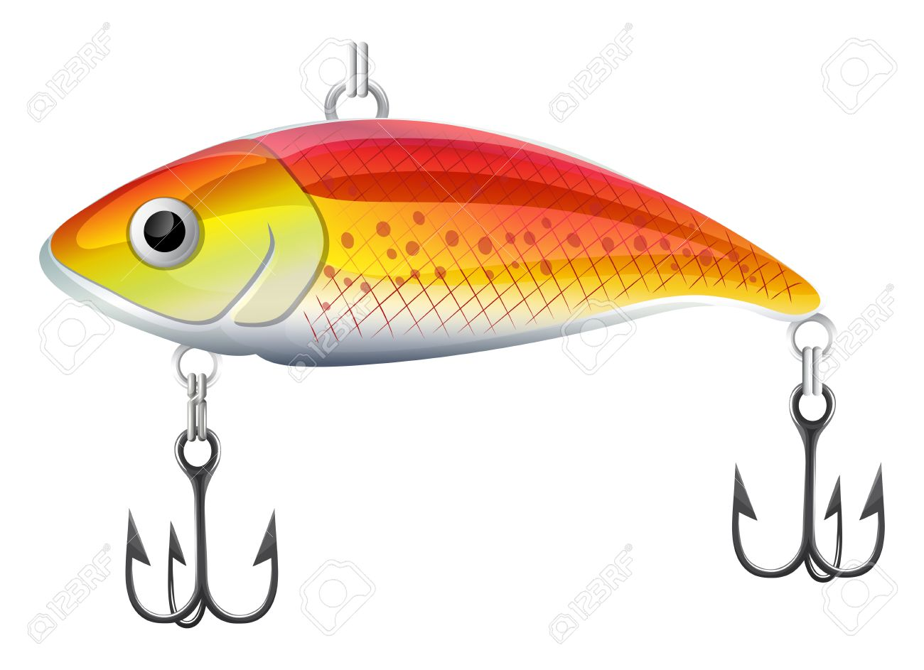  6:15 Bingo (3CHR) | 20  10:00 Putting Contest  (Outside AWR)  11:15 Boxing Club (3CHR)  2:00 Bingo Prize Cart (2CHR)  2:30 Quilting for a Cause (2CHR)  2:30 Bingo (2CHR)  4:00 Bible Study hosted by  Jehovah Witness’s (PDR)  4:00 Garden Club (3CHR)  6:30 MI History Group (PDR) | 21  9:30 Exercise (2CHR)  10:00 Living To Learn (3CHR)  11:00 Yahtzee (3CHR)  2:30 “Happy Hour” (2CHR)  3:10 “Happy Hour” (3CHR) | 22  9:30 Exercise (2CHR)  10:00 Rosary & Communion (AWR)  10:00 Bingo (3CHR)  11:15 Cardio Drumming (3CHR)  1:30 Laughter Yoga (AWR)  2:00 Bible Study (3CHR)  3:00 Euchre (3CHR)  4:15 Bird Care (Aviary 1CHR)  7:00 Thursday Night Special:  Double Play - Flute & Tuba (AWR) | 23  9:30 Exercise (2CHR)  10:00 Living to Learn (3CHR)  1:15 Wii Bowling (3CHR)  1:30 Art Appreciation Outing:  Saper Galleries (2RC)  2:30 Bingo (3CHR)  3:45 Piano w/ Marvin (3CHR)  4:00 Artist Studio (AWR) | 24  9:30 Exercise (3CHR)  10:30 Bingo (2CHR)  1:30 Movie Matinee (2CHR)  1:45 Farkle (3CHR)  3:00 Creative Expressions (3CHR)  3:00 Cardio Drumming (GLR)  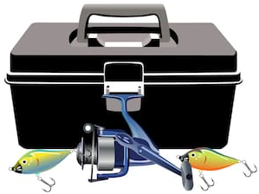
25  10:00 TV Mass (AWR)  10:00 Current Events (2CHR)  10:30 Religious Hymns on TV (2CHR)  10:45 “Old Time Religion” on TV (3CHR)  11:00 Artist Studio (3CHR)  1:15 Manicures (3CHR)  2:00 Chess (2CHR)  2:30 Bingo (3CHR)  4:00 Vespers (AWR) | 26  9:30 Exercise (2CHR)  10:00 Living To Learn (3CHR)  11:00 Quiddler (3CHR)  1:15 Word Searches (3CHR)  2:30 Music w/ Johnathon  Stars (AWR)  4:00 Garden Club (2CHR)  6:15 Bingo (3CHR) | 27  9:30 Exercise (2CHR)  10:00 Piano w/ Lorrie (3CHR)  10:45 FITness Class (3CHR)  11:15 Boxing Club (3CHR)  2:30 Quilting for a Cause (2CHR)  2:30 Bingo (2CHR)  3:00 3rd Floor Birthday Party (3CHR)  4:00 Bible Study hosted by  Jehovah Witness’s (PDR)  6:30 MI History Group (PDR) | 28  9:30 Exercise (2CHR)  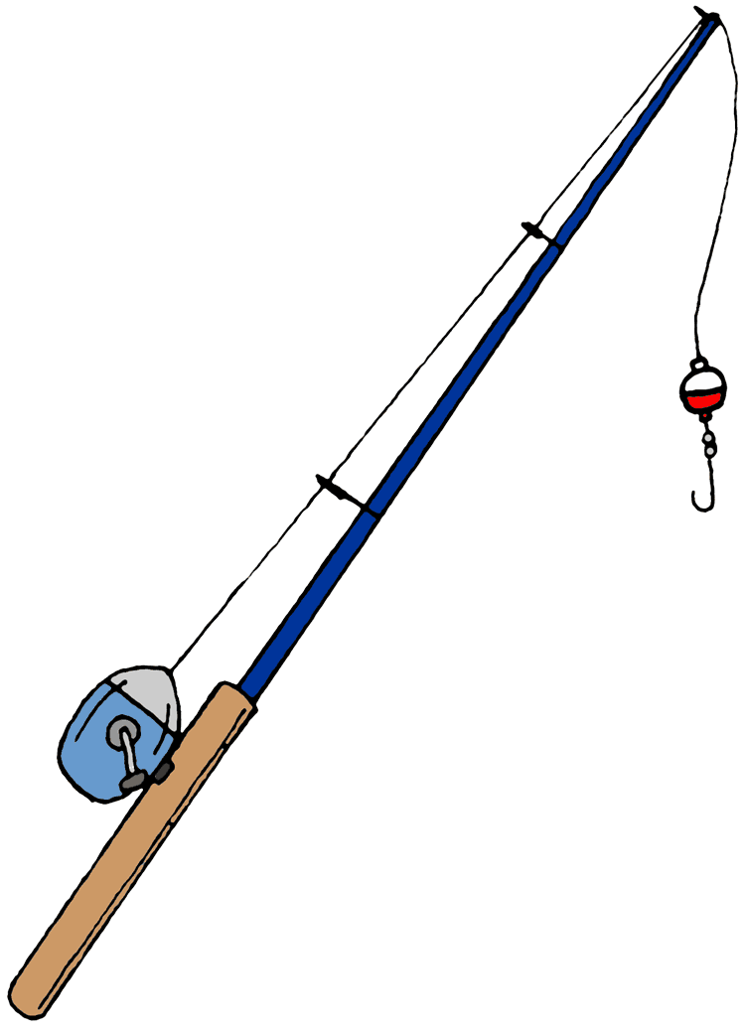  10:00 Living To Learn (3CHR)  11:00 Yahtzee (3CHR)  11:00 Resident Council (3CHR)  2:00 Cooking Group (2CHR)  4:00 Basketball Toss (3CHR) | 29  9:30 Exercise (2CHR)  10:00 Rosary & Communion (AWR)  10:00 Bingo (3CHR)  11:15 Cardio Drumming (3CHR)  1:30 Laughter Yoga (AWR)  3:00 2nd Floor Birthday Party (2CHR) | 30  9:30 Exercise (2CHR)  10:00 Living to Learn (3CHR)  11:30 Pig Pickin’ Labor Day with  Ricky & Karen (carports)  1:15 Wii Bowling (3CHR)  2:30 Bingo (3CHR)  3:45 Manicures (2CHR) | 31  9:30 Exercise (3CHR)  10:30 Bingo (2CHR)  1:30 Movie Matinee (2CHR)  1:45 Farkle (3CHR)  3:00 Michigan History (3CHR)  3:00 Cardio Drumming (GLR)

